**GuviTask6 Outputs**

1. **Palindrome**

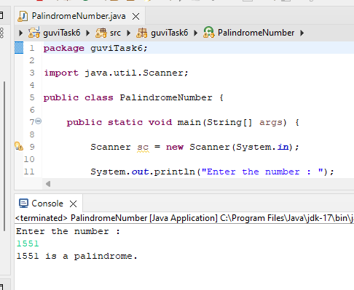

1. **Reverse String**

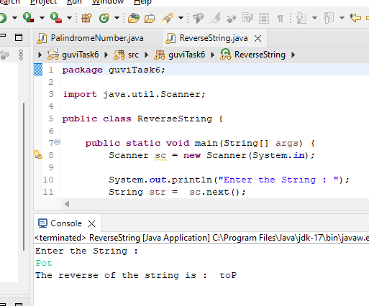

**3.NumberPattern**

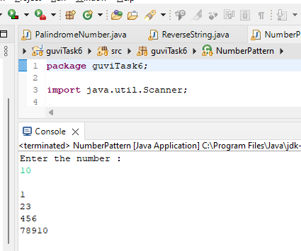

**5. Grading System**

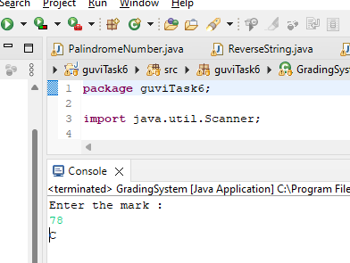

**7. LargestAmongThreeNumbers**

